Course Title: Reading Food Labels

Grade Level: High School 9-12

Description:
In this course, you will learn about reading food labels. The importance of this course is to teach you how to figure out what ingredients are in the food you eat, the amount of nutrients the food provides, and how to calculate the daily percentages of nutrients you get.

Course Image:
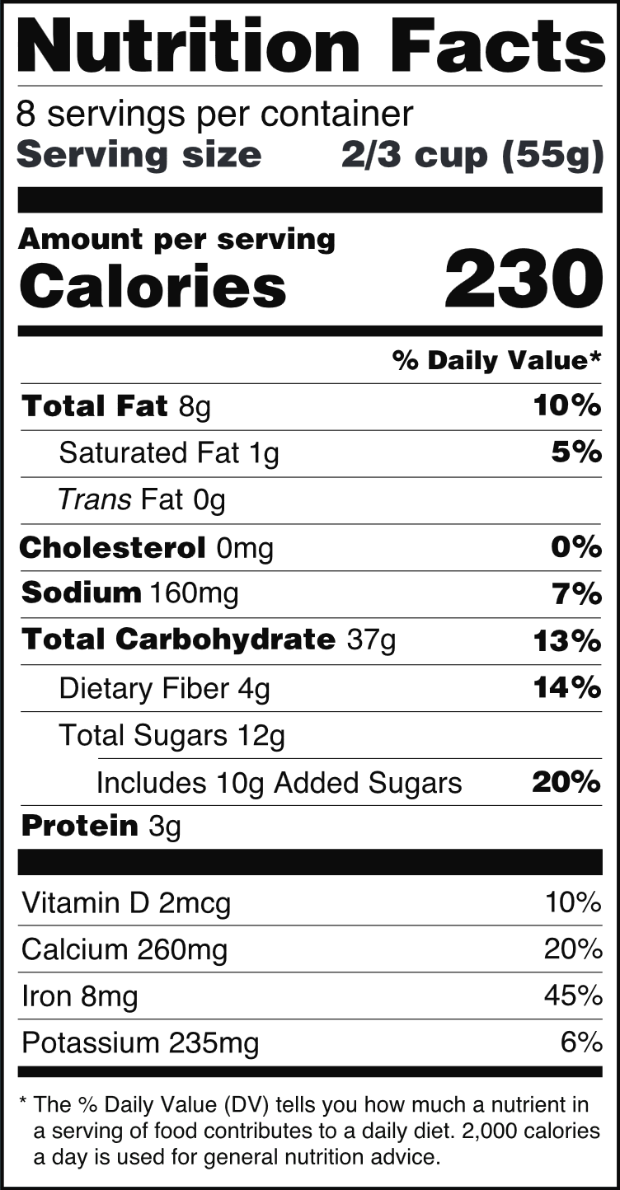
Video URL:
https://www.youtube.com/watch?v=s5zroZfMn0I

